Date: 26.02.2021
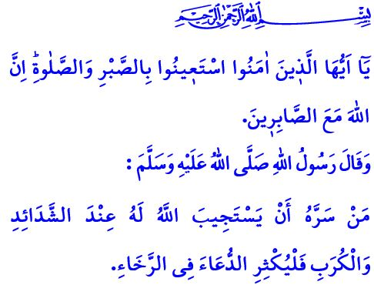
Finding Strength in Our Spirituality in Difficult Times
Honorable Muslims!
In the verse I have recited, our Lord Almighty states as follows, “O you who have believed, seek help through patience and prayer. Indeed, Allah is with the patient.”
In the hadith I have recited, the Prophet Muhammad (saw) says, “Whoever wants their prayers to be accepted through difficult times should pray a lot through normal times.”
Dear Believers!
During our time in this life, many problems, sorrows and troubles come in our way. Every incident that occurs to us is part of the test in this world, regardless of its consequences. What we call as the life capital is actually a limited time frame given to us. What is important is to spend this period of time faithfully by doing righteous deeds, and to maintain a right stance in the face of the incidents we encounter. As a matter of fact, the Almighty Allah (swt) states in the Holy Qur’an as follows: “We will surely test you with something of fear and hunger and a loss of wealth and lives and fruits. Give good tidings to the patient!”
Dear Muslims!
We should find strength in our love for and trust in Allah (swt) in our good days as well as in our bad days. Our primary responsibility as Muslims in the face of the challenging trials of life is to take all measures within our power. It is to adopt a calm and resilient approach to the incidents and to exert efforts in finding solutions to them. It is to never fall hopeless and never lose our faith and resilience.
Dear Muslims!
Muslims, who resort to causes and take all kinds of measures in the light of knowledge, reason and experience, should also know to trust Allah (swt) and be contented with the divine decree. They should act with submission and calm, not rebellion and extremism. They should get rid of their fears, worries and pessimism, and seek refuge in the absolute will of Allah (swt). For the safest haven is the Almighty Allah’s (swt) matchless might, knowledge, wisdom, aid, and grace. It is the light for a Muslim’s life to not lose faith in Him (swt) even for a moment, to lean on Him, trust in Him, and ask Him for help. It is the essence of the servitude to Allah (swt) to seek refuge in Him (swt) through prayers and supplications, repentance and asking for forgiveness, and thankfulness and gratitude.
Dear Believers!
The Prophet Muhammad (saw) says in one of his hadiths as follows, “How nice is the state of a believer! There is good in every affair of his, which is special to believers only. For if he has an occasion to feel delight, he shows gratitude and this is good for him. And if he gets into trouble and shows resignation (and endures it patiently), there is a good for him in it.”
Therefore, let us not forget that Muslims can overcome their difficulties by relying on their Lord (swt), feeling confident in themselves, and helping and getting help from their brothers and sisters. Let us read the incidents we experience through a reflective and insightful perspective. Let us look at them with the sense of responsibility and of reviewing our own self. Let us make sure that we fulfill what falls upon us. Let us weigh the tests of this world using the scale of devoutness, patience and gratitude. Let us keep vivid our spirituality through worship, supplication, contemplation and reliance on Allah (swt) in order to be strong in life.

Baqarah, 2/153.
Tirmidhi, Daʻawat, 9.
Baqarah, 2/155.
Muslim, Zuhd, 64. General Directorate of Religious Services

